Unable to view saved MOA for particular test. And not having save tab for all test MOA also tab for download MOA is missing.
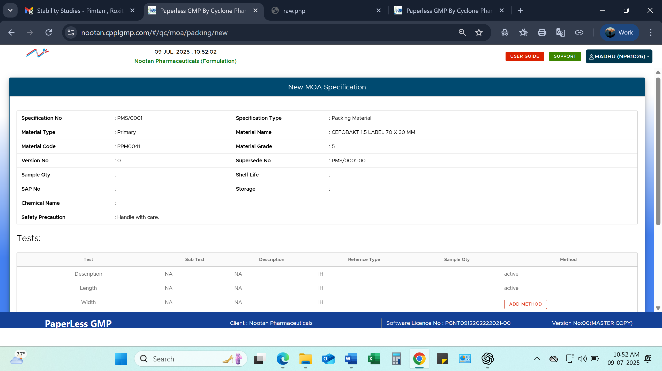

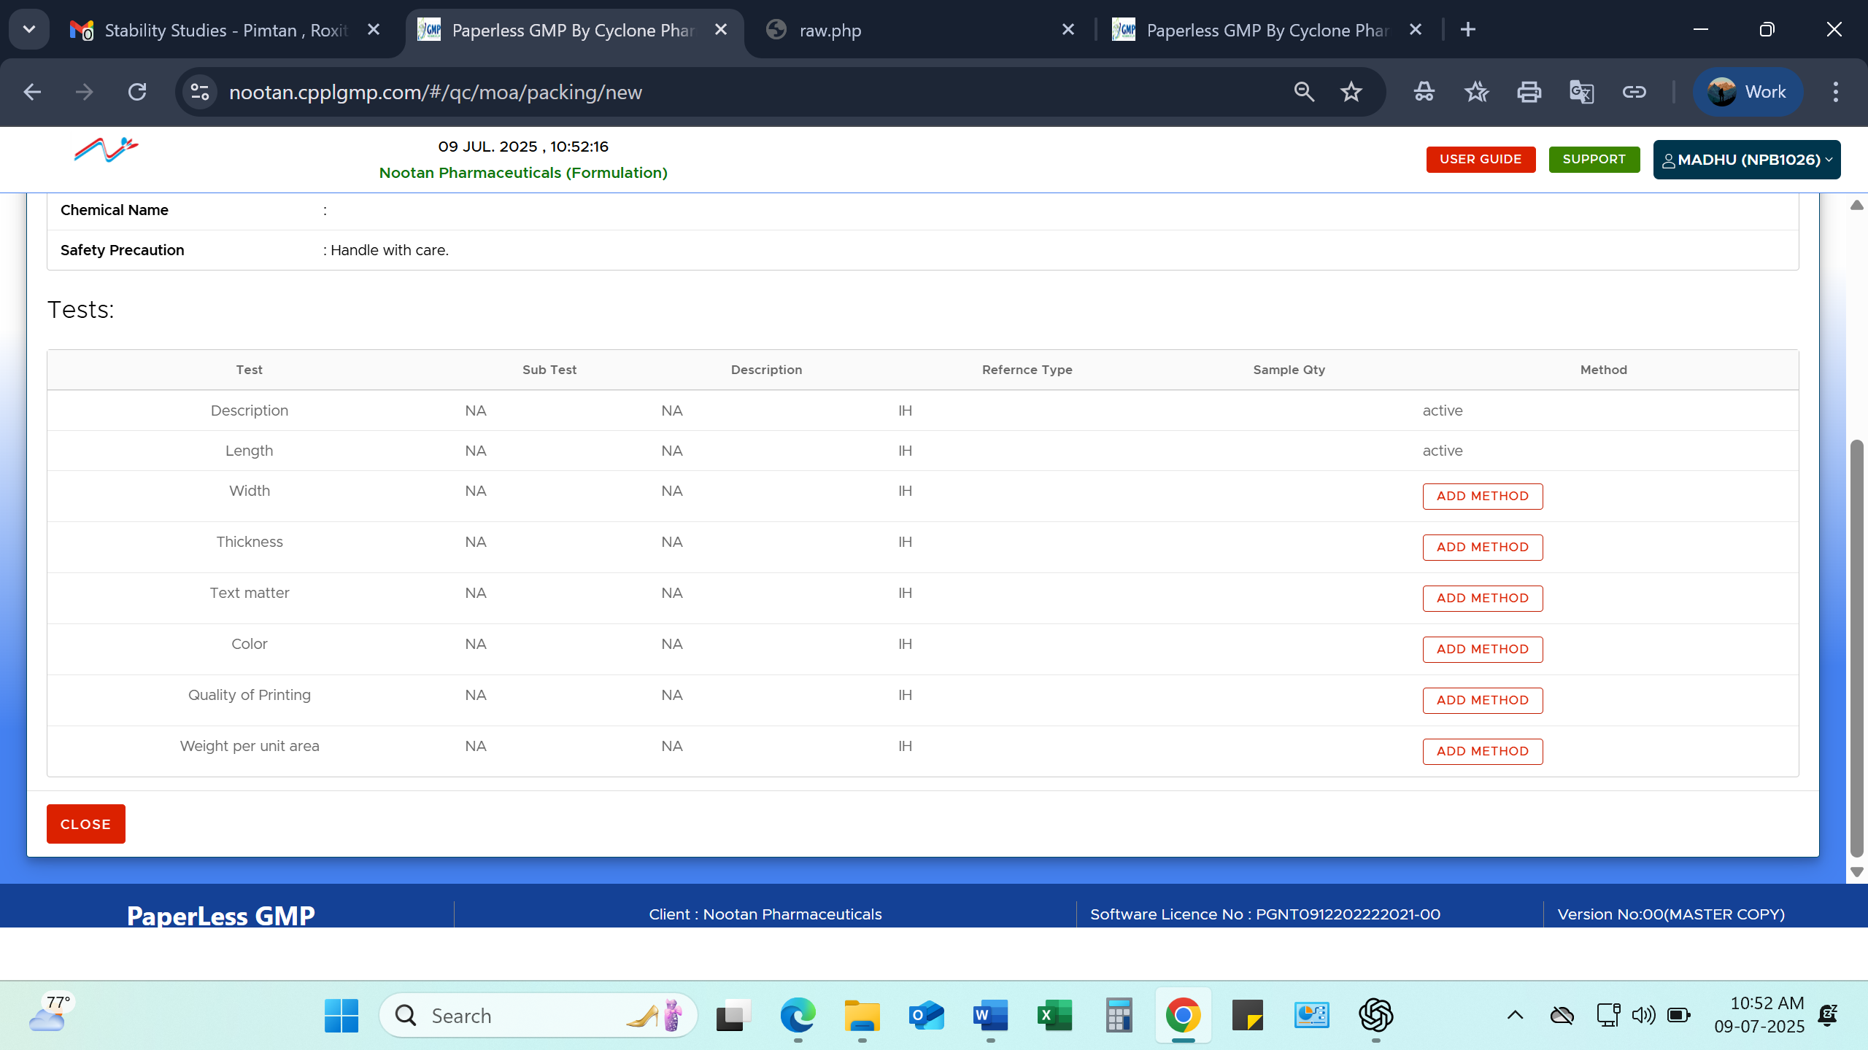

Following Corrections are necessary.
Material Grade: 5 (Required Grade Name)
Supersede No: PMS/0001-00 (Required NA as it is new specification.)
Following details not required in Header part.
Sample Qty
Shelf Life
Storage
Chemical Name
Safety Precaution

