Raw Material Specification Report…Query 2(A)
Specification Preparation Module
Review date tab not required as discussed earlier.
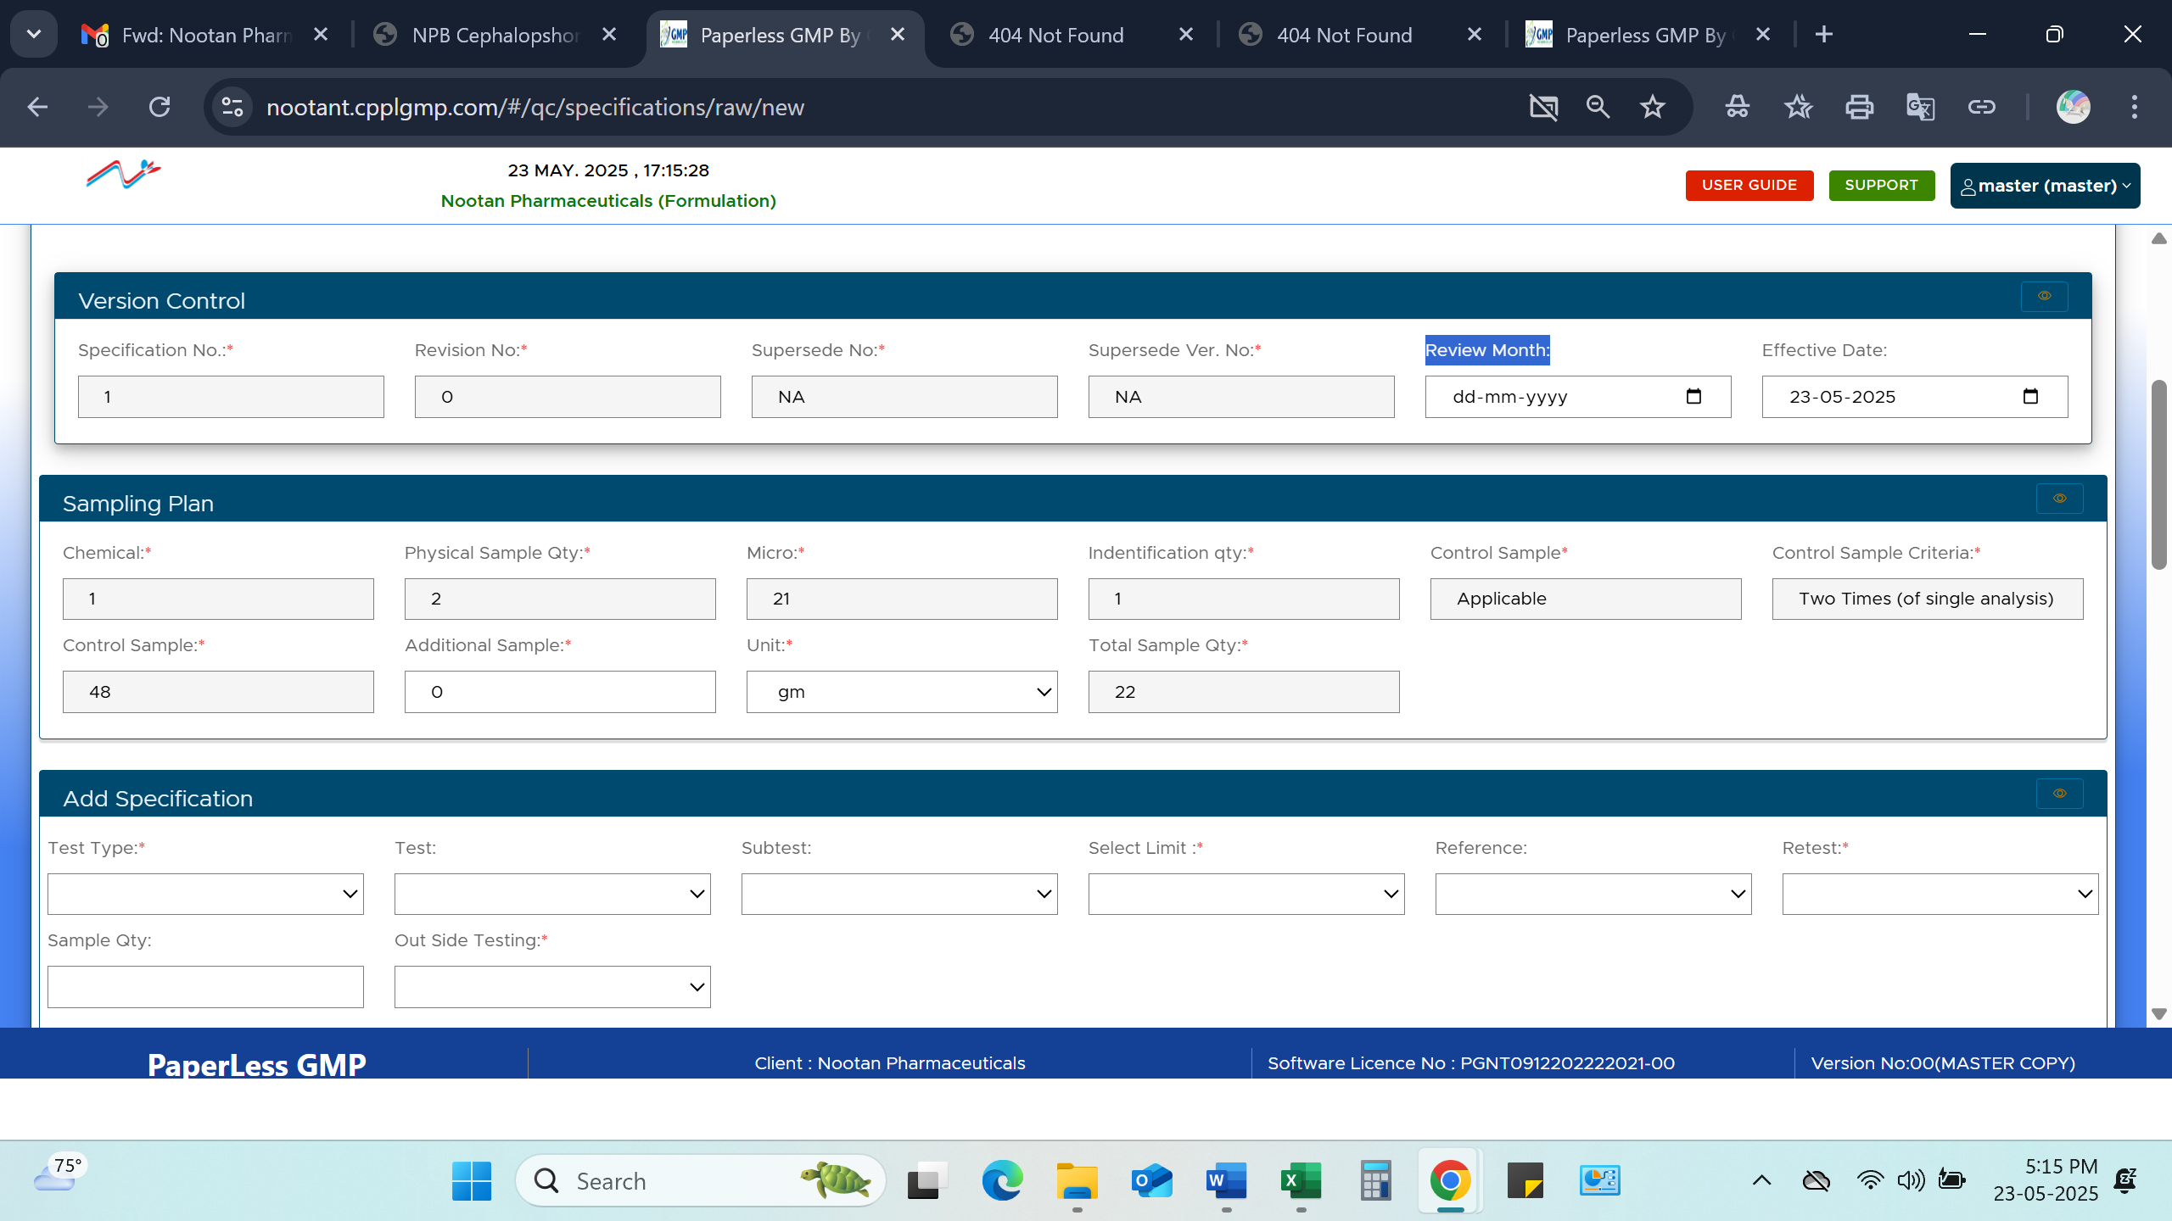
Instrument test type missing in Sampling Plan
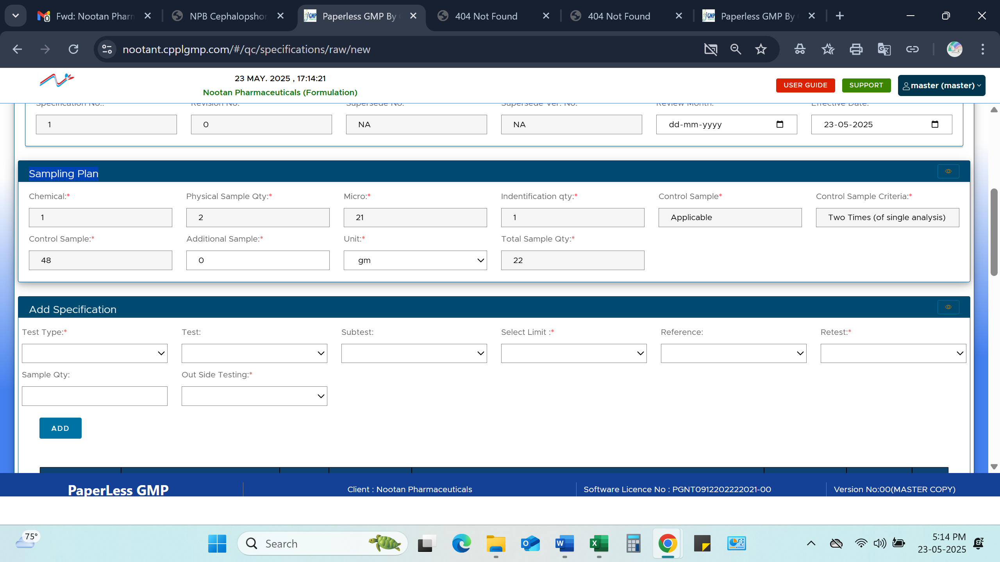

All test type not available in dropdown list for Client specific test
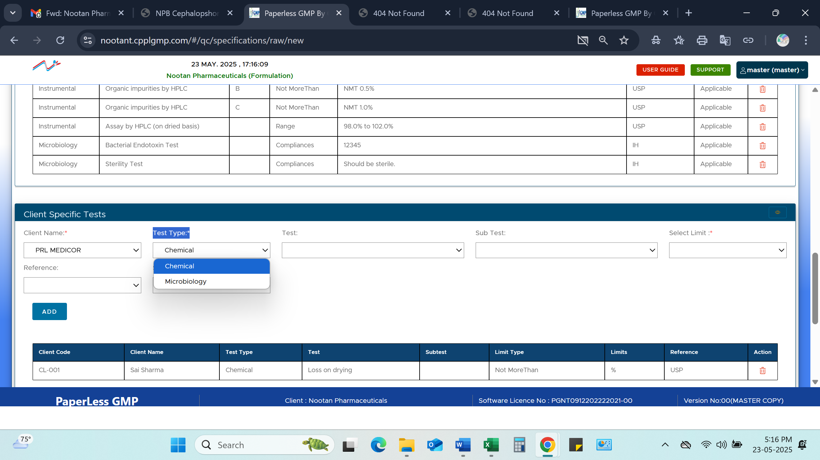
IH is not available in reference as earlier added in regular specification test.
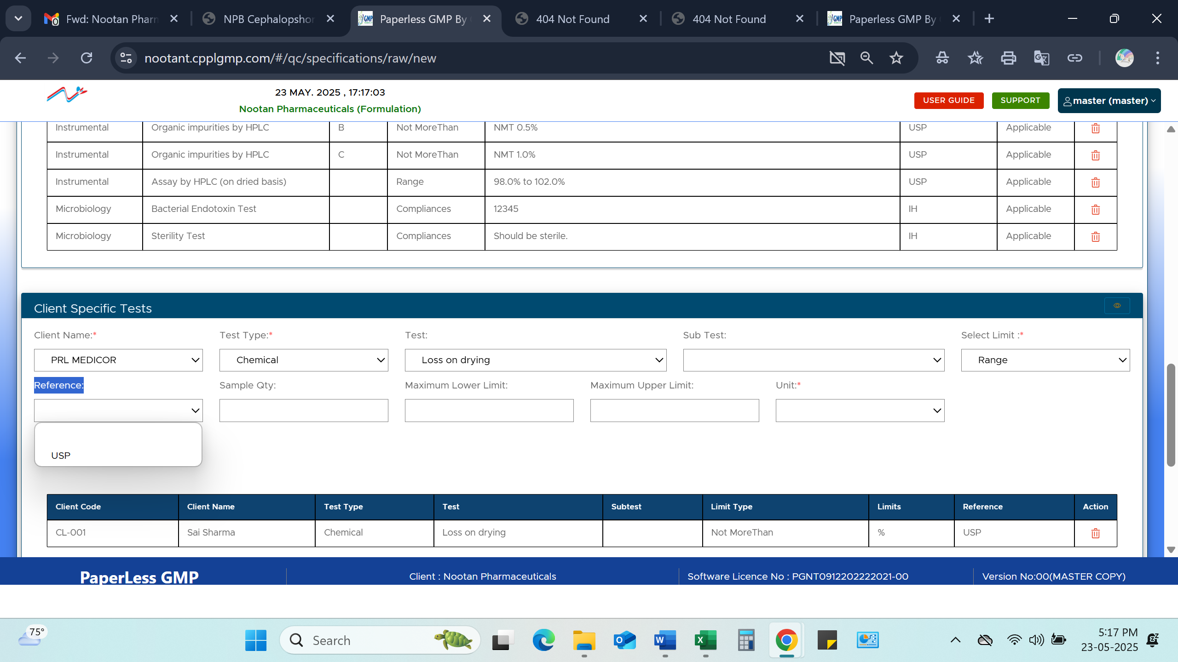

As it is 1st time new specification preparation still number observed with revision no 1 and superseded with revision no. 0 …..How is it possible…Pls explain.
Other Points
Date format is not inline as per DD/MM/YYYY
Reason for change should be available to mention reason.
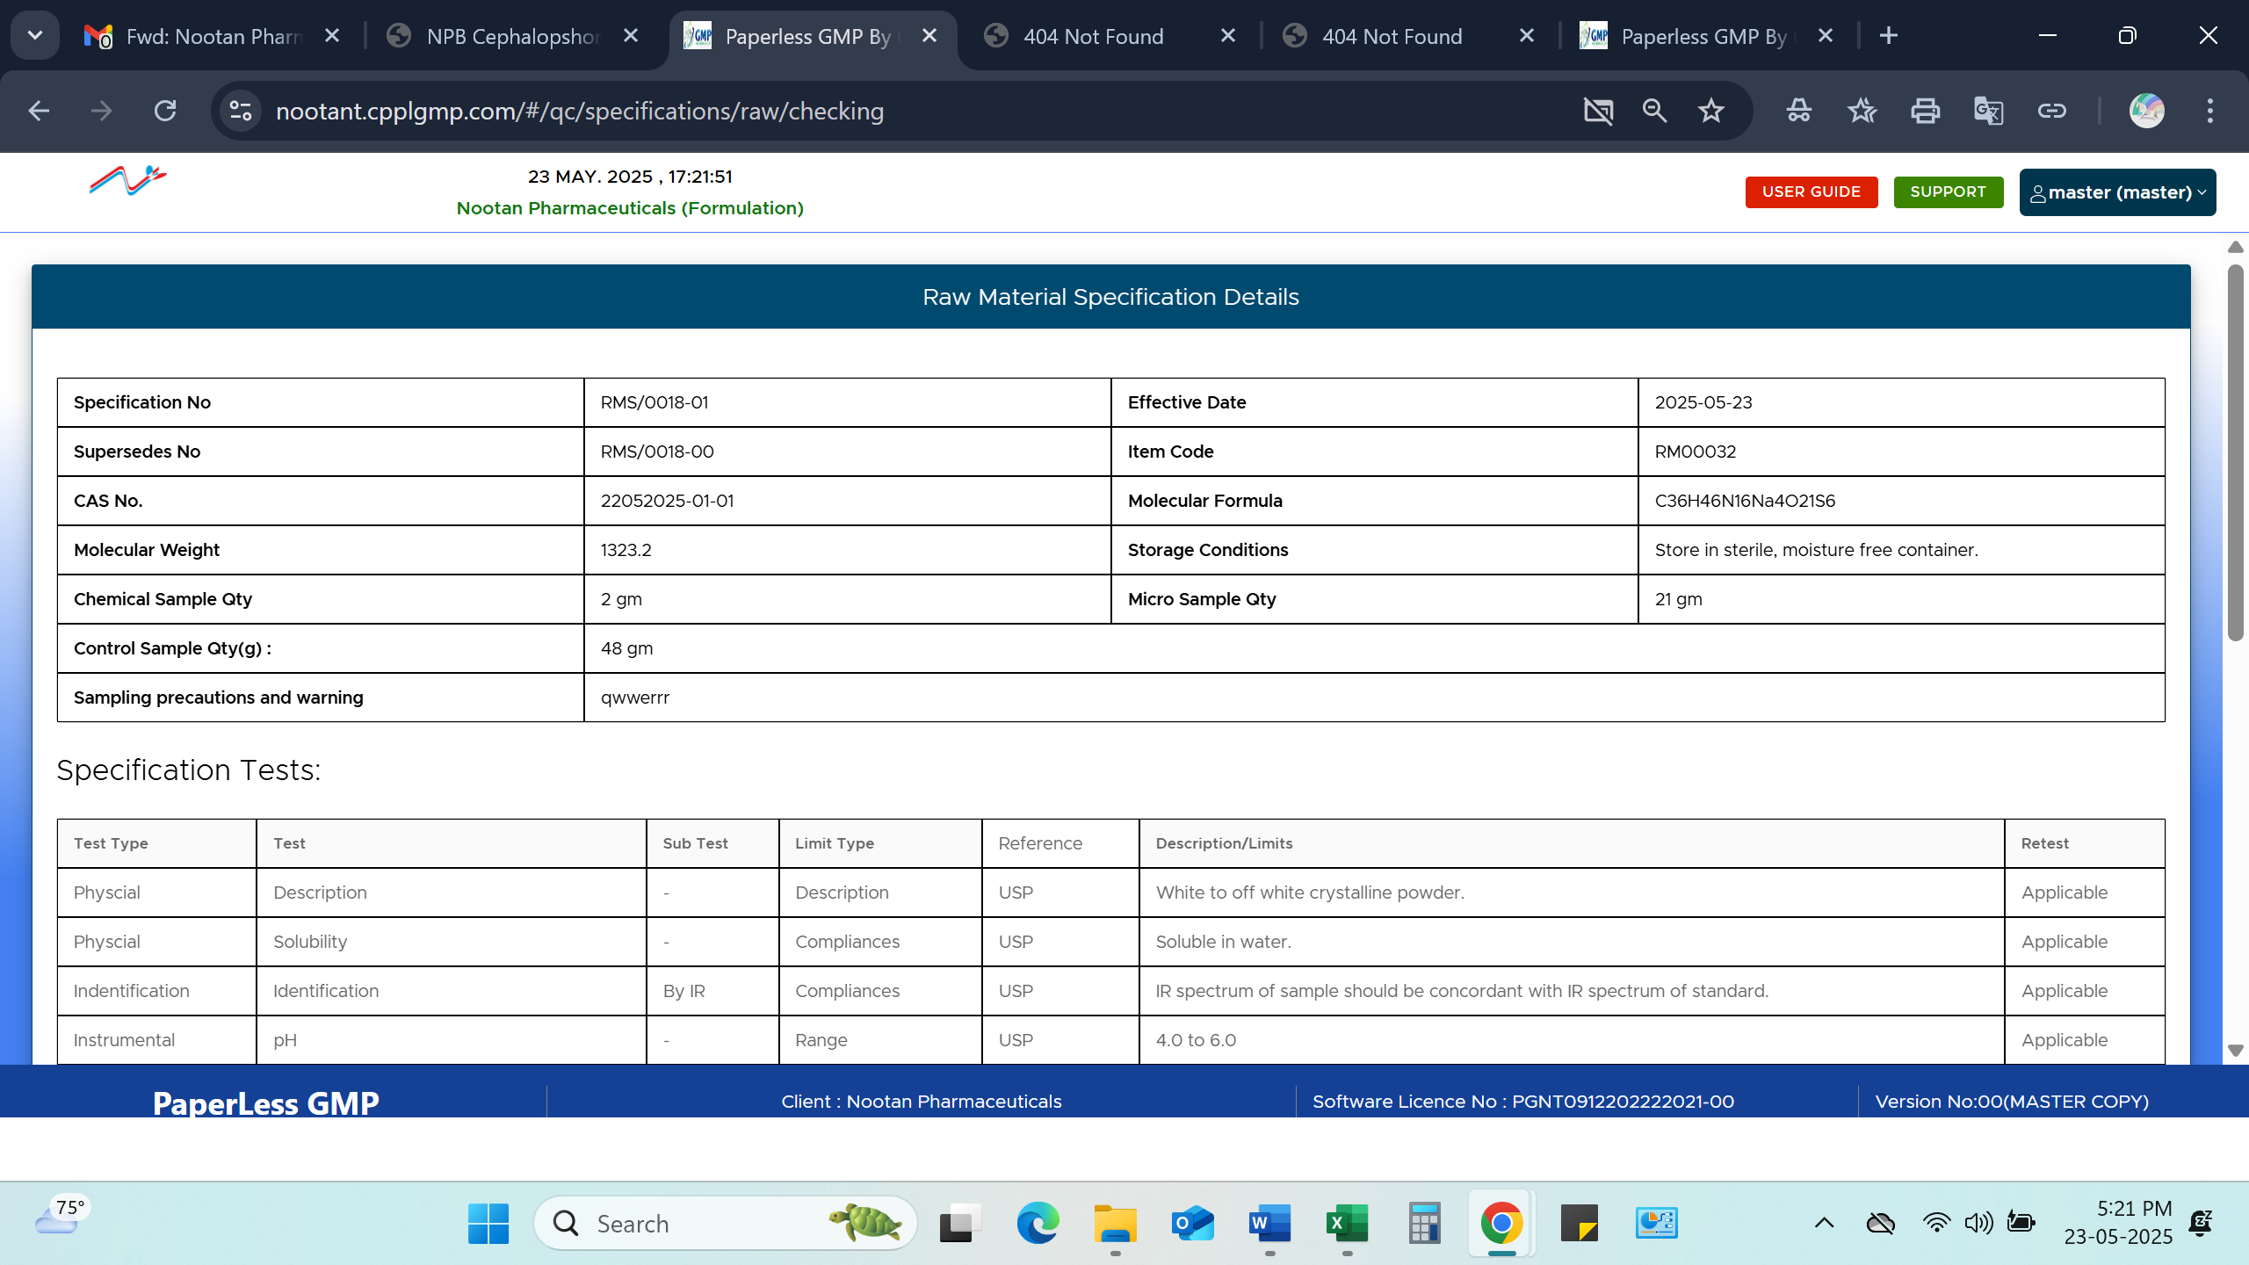
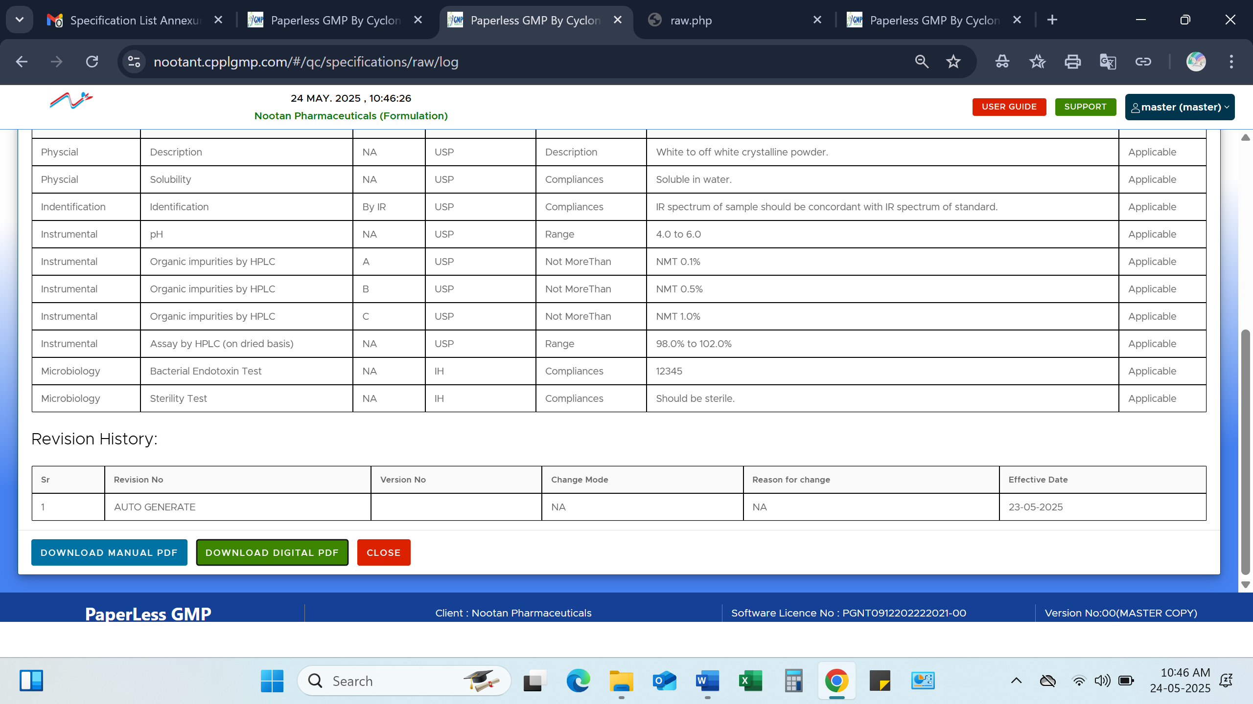
Raw Material Specification PDF…Query 2(B)
Header is not in line as per data entered
Points:
Required Specification No. only
Date format
Revision No.
Subtest not shown
Client specific test’s limit not reflecting. And client name is also required.
Revision history is also not completed.
I selected IH grade for Micro test, but it is not reflecting in PDF. (Reflecting in report)
